Computer Room Air Conditioner

General

The computer room is cooled by a 5 ton air conditioner. The compressor and condenser part of the unit is located outside on the north wall of the Ops Bldg. Under the window by Dave Woods desk. The evaporator is integral to the blower /fan unit in the computer room.

The compressor starts and stops as required to maintain temperature in the room at 70 degrees. There is no heat just cooling available. The fan/blower unit runs continuously. There is also 2 humidifiers that are run with the blower and use RO water from under the sink in the main bathroom.

The blower has been equipped with a automatic temperature and humidity controlled louver that will let outside air in if the temperature is below a certain temperature (currently set at 55 deg) and below a set humidity (currently set at 60%) . This functions as an economizer reducing the run time on the compressor during times when the outside is cold enough to maintain the temperature in the room.

There is also a temperature alarm (see fig 4) by the fax machine that indicates if the computer room air conditioner is down by alerting when the temperature gets too high. It is essential that quick action be taken once the room temperature gets above 75 deg to avoid hardware failure.

Common failure modes:

1. Fan blower motor fan belt breaks

2. Compressor stops for high or low pressure

3. Compressor trips on incoming power

4. Evaporator coils freeze up

In all of these cases knowledge of mechanical/electrical and HVAC systems is required to fix the problem. As a result we have implemented procedures to bring in outside air to help cool the room. We will also need to start turning off unused equipment and heat loads. The success of these procedures will depend to large extent what the outside temperature is. If hot outside we will likely have to shut down all essential computers and will not be able to observe. This needs to start as soon as possible.

What to do when the temperature alarm goes off:

1. Go into the computer room and verify if the fan/blower is running

1a. Determine outside air temp

2. Call Fritz or Jon B.

3. Call Mark or Ben (I’ll need to know the answers to 1 and 1a.)

If the fan/blower unit is running then immediately :

1. On right side of blower unit move toggle switch to “Bypass”
(see Fig 1)
You should hear if the outside louver motor opens
If so great , regardless continue

2. On left side of outside air inlet on the exterior east wall of the ops bldg slide up the cover plate on the small box attached to the hood and set temperature controller to 0 deg (see Figure 2 and 3 )

If louver motor did not activate in step 1 it should now unless it was
already open

3. Prop open door to computer room

4. Close door by bathroom to instrument lab

5. Close door to Ops extension area

6. Close door between kitchen and supply area

7. Close all outside ops bldg doors doors/windows

8. Open door to 3.5m Arcade

9. Turn on Arcade fan by selecting “hand” on the front panel
Arcade Fan should start – lots of noise (see Fig 5)

10. Get large grey fan (5ft tall) (see Fig 7) from base of 3.5m and roll down to computer room

11. Set fan in door way of computer room and turn on , out blowing air out of the computer room.

12. If outside temp is warmer than 30 degs---
There is a small louvered vent in the upper right corner on the east wall of the computer room, Remove screen and prop this louver open

13. Monitor room temperature

14. If temperature exceeds 80 deg and you can not reach Fritz or Jon start shutting down all equipment in the computer room that you know how to.

If the fan/blower unit is NOT running then immediately :

1. on right side of blower unit move toggle switch to “Bypass”
(see Fig 1)
You should hear if the outside louver motor opens
If so great , regardless continue

2. Behind the fan/blower unit is a box that directs air from the outside louvers to the fan. There is a cover on this box held by a couple sheet metal screws. Remove this top cover. (see Fig 6)

3. On left side of outside air inlet on the east exterior wall of the ops bldg slide up the cover plate on the small box attached to the hood and set temperature controller to 20 deg (see Fig 2 and 3)

If louver motor did not activate in step 1 it should now unless it was
already open

4. Prop open door to computer room

5. Close door by bathroom to instrument lab

6. Close door to Ops extension area

7. Close door between kitchen and supply area

8. Close all outside ops bldg doors doors/windows

9. Open door to 3.5m Arcade

10. Turn on Arcade fan by selecting “hand”
Arcade Fan should start – lots of noise (see Fig 5)

11. Get large grey fan (5ft tall) from base of 3.5m and roll down to computer room. (See Fig 7)

12. Set it near the fan/blower unit and turn on blowing air down the computer room towards the door.
13. In the base of the 3.5m telescope get all of the box fans available and set up in computer room to circulate air towards the door.

13. There is a small louvered vent in the upper right corner on the east wall of the computer room, Remove screen and prop this louver open

13. Monitor room temperature

14. If temperature exceeds 82 deg and you can not reach Fritz or Jon start shutting down all equipment in the computer room that you can.

Fig 1
Fresh air inlet louver bypass and humidity control

Fig 2

Fresh air inlet

Fig 3
Fresh air inlet louver temperature control

Figure 4
Computer Room Temperature alarm

Fig 5
Arcade Fan controller
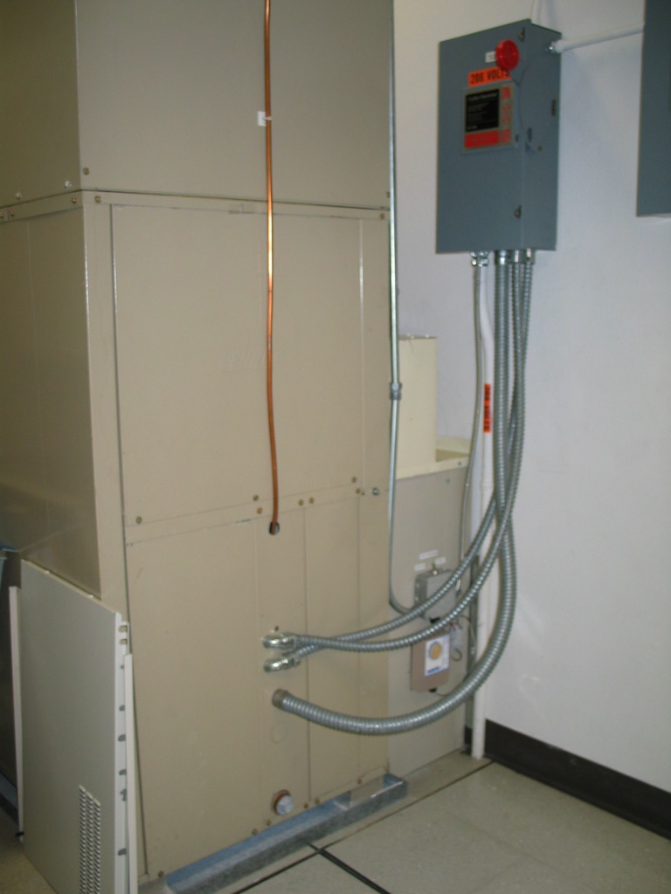

Fig 6
Computer Room Fan/Blower unit
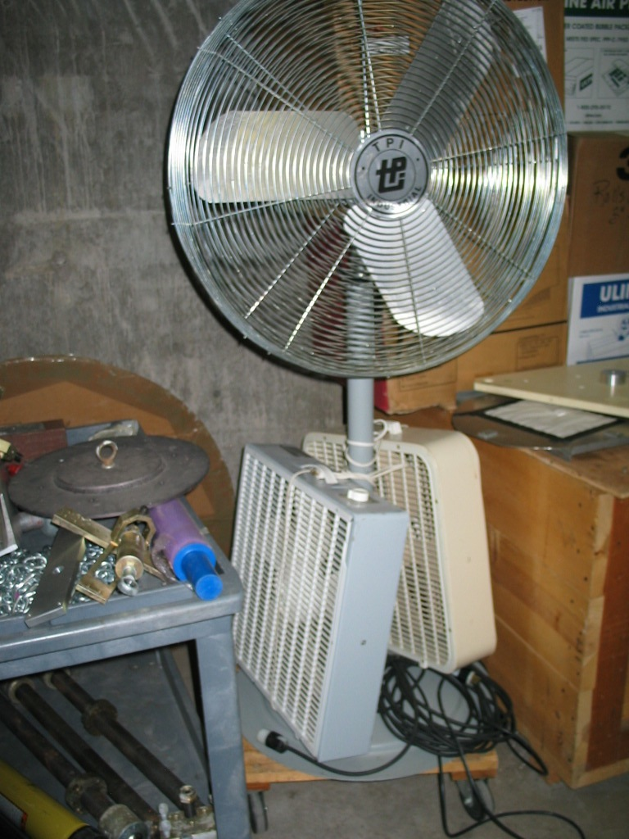

Fig 7
Extra fans

